Experiment Results:
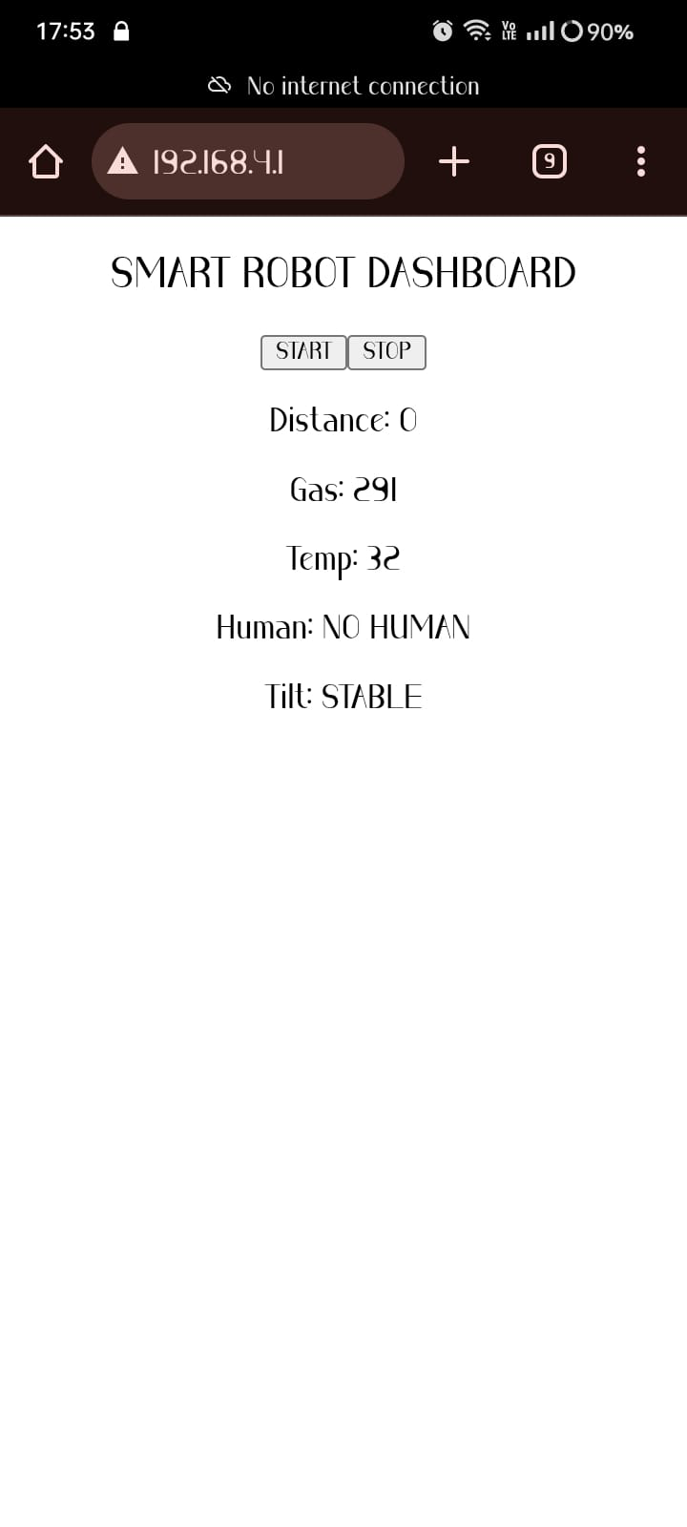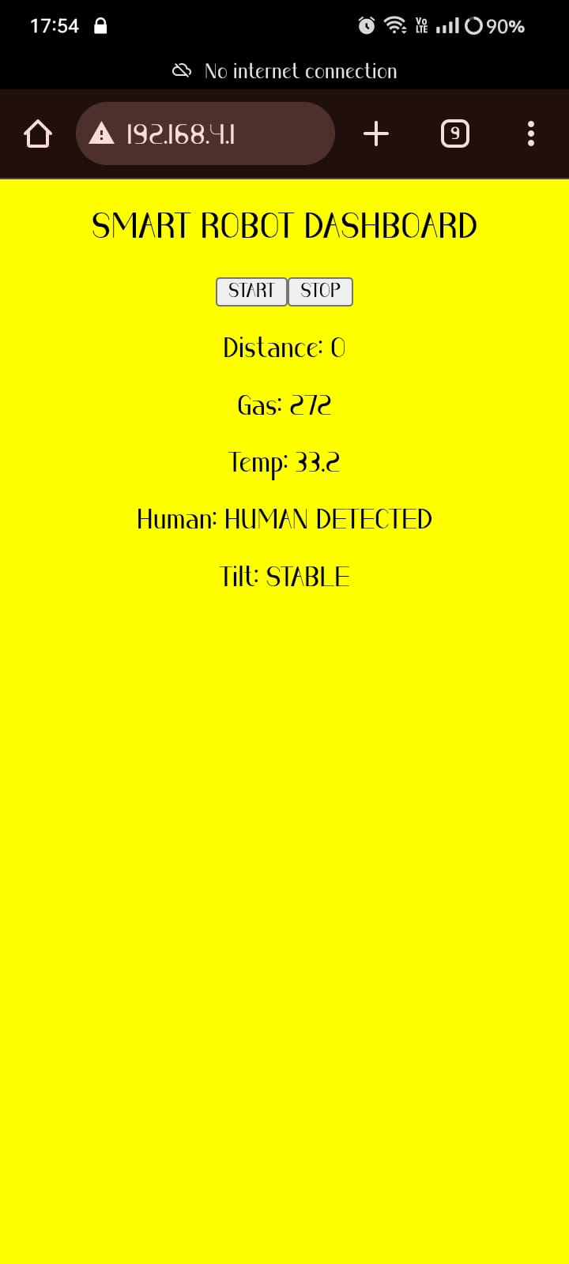

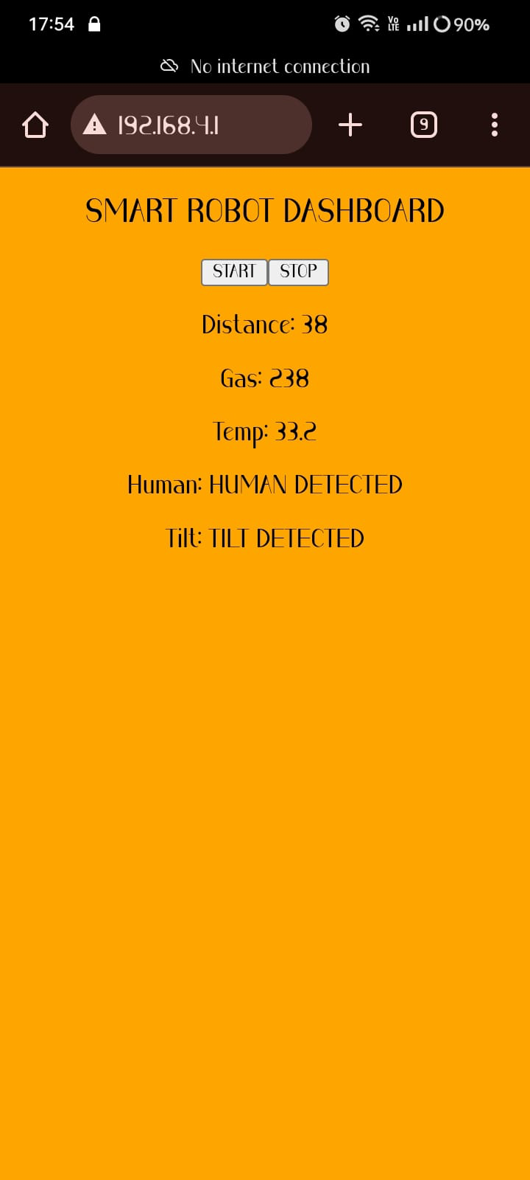

Discussion:
The proposed Autonomous IoT Surveillance Robot demonstrates effective integration of thermal sensing, obstacle detection, and gas monitoring using the ESP32 platform. The system provides key functions such as human detection through thermal imaging, real-time obstacle distance measurement, environmental gas monitoring, and wireless IoT-based live data visualization. The visual alert mechanism (screen turning orange) enhances quick identification of human presence. By combining multiple sensors, the robot improves accuracy and reduces false detection compared to single-sensor systems.
This system can be used in smart security surveillance, industrial safety monitoring, hazardous gas detection areas, defense applications, warehouse monitoring, and night-time security operations. Although the thermal sensor has limited 8×8 resolution and moderate range, the overall system offers a cost-effective, energy-efficient, and reliable solution for autonomous monitoring and smart inspection tasks

